# **Game Design Document (GDD) Template**

## **1. Game Overview**

* **Game Title:** *(Choose a name that fits the theme and gameplay.)*
* **Genre:** *Metroidvania, 2D Platformer, 2D action*
* **Target Audience:** *Kids, Casual Gamers*
* **Platform(s):** *PC*
* **Game Summary:** A high mobility heist game about navigating difficult terrain in a futuristic tower complex. The game will include a bit of combat, parkour-based platforming, and metroidvania elements.

🔹 *Hint: Keep this section clear and concise—it’s your elevator pitch!*

## **2. Core Gameplay & Mechanics**

* **Game Objective:** The player will play a member of a group trying to rob a technological facility. This will be achieved through platforming and light combat, along with collecting keycards.
* **Core Mechanics:** Jumping, Running, Rolling, and Wall Jumps.
* **Game Loop:** Jump over and on platforms -> Find a keycards -> Open a Door
* **Difficulty & Progression:** Areas introduce new hazards and more complicated obstacles. Along with a few beefier enemies.
* **Jumping:** Bound to the spacebar, the player jumps when pressed.
* **Running**: Bound to W,A,S,D default movement
* **Rolling:** Bound to spacebar, activatable while falling, negates fall damage if clicked right before hitting the ground.
* **Wall Jumps**: The player can stick to walls and slide down them if pressing the direction key that presses them further into the wall.

🔹 *Hint: Focus on making a simple, fun, and polished core experience!*

## **3. Story & Theme**

* **Theme:** Cyberpunk, Futuristic
* **Setting:** *Futuristic City*
* **Main Character(s):** A highly mobile robber.
* **Plot Summary:** The Player is attempting to break into a technological complex to steal loot.

🔹 *Hint: Keep the story relevant to gameplay—don’t overcomplicate it!*

## **4. Level & World Design**

* **Number of Levels:** 4
* **Level Structure:** Metroidvania, with parts of levels restricted by certain prerequisites such as keycards.
* **Exploration & Navigation:** 2D platformer.
* **Interactive Objects:** Keycards, Weapons, Doors.

🔹 *Hint: Your first level should be a safe area to introduce mechanics to the player.*

## **5. Characters & NPCs**

* **Main Character:** A highly mobile robber.
* **Enemies/Obstacles:** A ranged drone, and a melee robot.
* **NPCs:** A person on a walkie talkie guiding the player through the complex

🔹 *Hint: Keep character abilities simple and focused on gameplay fun.*

## **6. Art & Sound**

* **Art Style:** Bright, colorful, simplistic
* **User Interface (UI) Design:** Holograms
* **Sound Design:** Techno music, metallic echos, large industrial noises

🔹 *Hint: Use placeholders first, then refine assets as the game progresses.*

## **7. Technical Aspects**

* **Game Engine:** *Unity (2022 LTS preferred for WebGL projects).*
* **Controls:** Keyboard
* **Physics & Interaction:** Physics, fall damage.

🔹 *Hint: Make sure controls feel intuitive and responsive!*

## **8. Development Timeline & Milestones**

* **Phase 1: Concept & Planning (Week 1) → Define mechanics, story, and theme.**
* **Phase 2: Prototyping (Weeks 2-3) → Build core gameplay mechanics.**
* **Phase 3: Alpha Testing (Week 4) → Playtest, refine mechanics.**
* **Phase 4: Beta Testing (Week 5) → Polish, fix bugs, finalize assets.**
* **Phase 5: Submission (Week 6) → Upload game, finalize Itch.io page.**

🔹 *Hint: Stick to deadlines and test your game often!*

## **9. Team Members & Roles**

* **Game Designer:** *(Oversees gameplay mechanics and design.)*
* **Programmer(s):** *(Implements mechanics, UI, and systems.)*
* **Artist(s):** *(Creates character sprites, backgrounds, UI.)*
* **Sound Designer:** *(Handles music and sound effects.)*
* **Level Designer:** *(Builds and organizes game levels.)*
* **Project Manager:** *(Tracks progress, organizes meetings, and ensures deadlines are met.)*

🔹 *Hint: Communication and collaboration are key!*

## **10. Submission & Final Steps**

* **Playable Version:** *(Ensure the game runs smoothly and is exported as HTML5/WebGL.)*
* **Itch.io Page:** *(Include game description, controls, screenshots, and credits.)*
* **Feedback & Playtesting:** *(Get testers to try your game and make final adjustments.)*
* **Final Submission:** *(Submit through the official form and ensure all requirements are met.)*

🔹 *Hint: Test your game before submitting to avoid last-minute issues!*

## **11. NPC Designs**

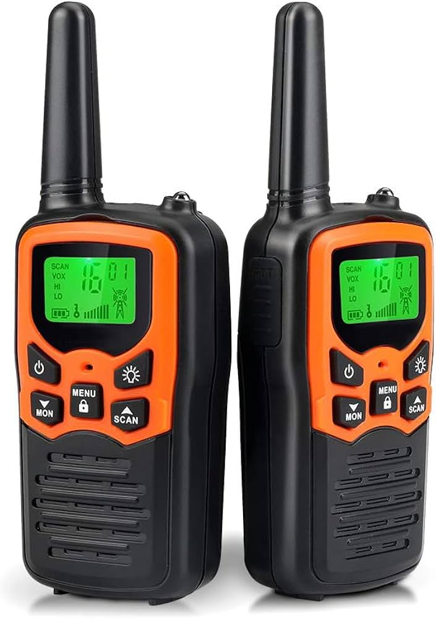

The player has a walkie talkie where their boss instructs them how to navigate the facility.

Will just be a sprite in a dialogue box.

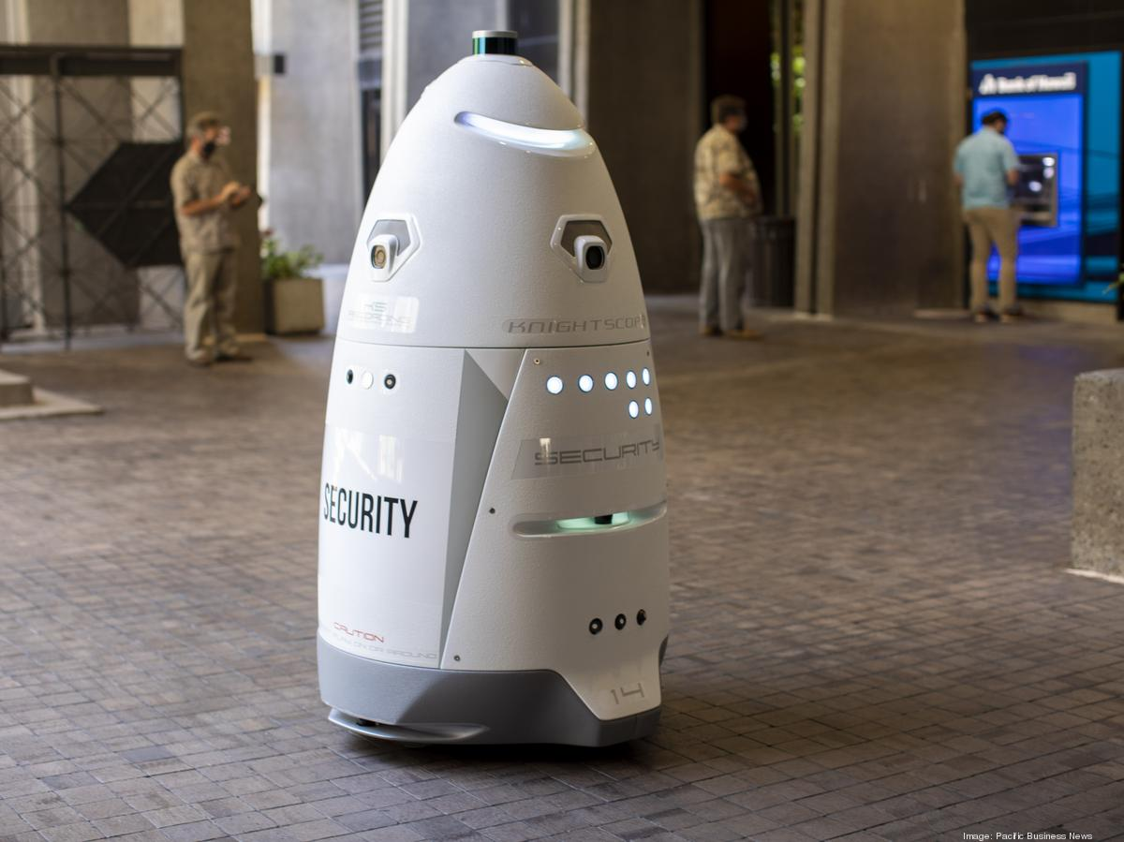

A melee security robot that attacks the player if they move onto the platform it inhabits.

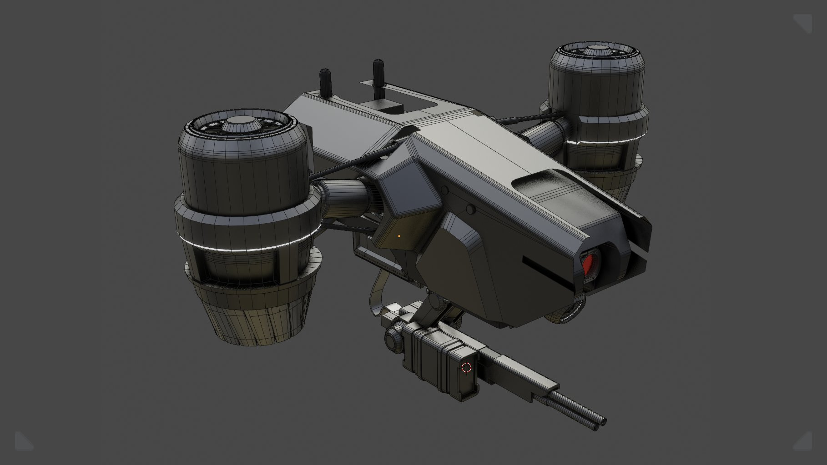

A ranged, flying drone with a gun that fires at the player with energy weapons.